Appendix B

Automatic Robot Driving Circuits

B.1 automatic robot no.1

B.1.1 Schematic of motors driving circuit
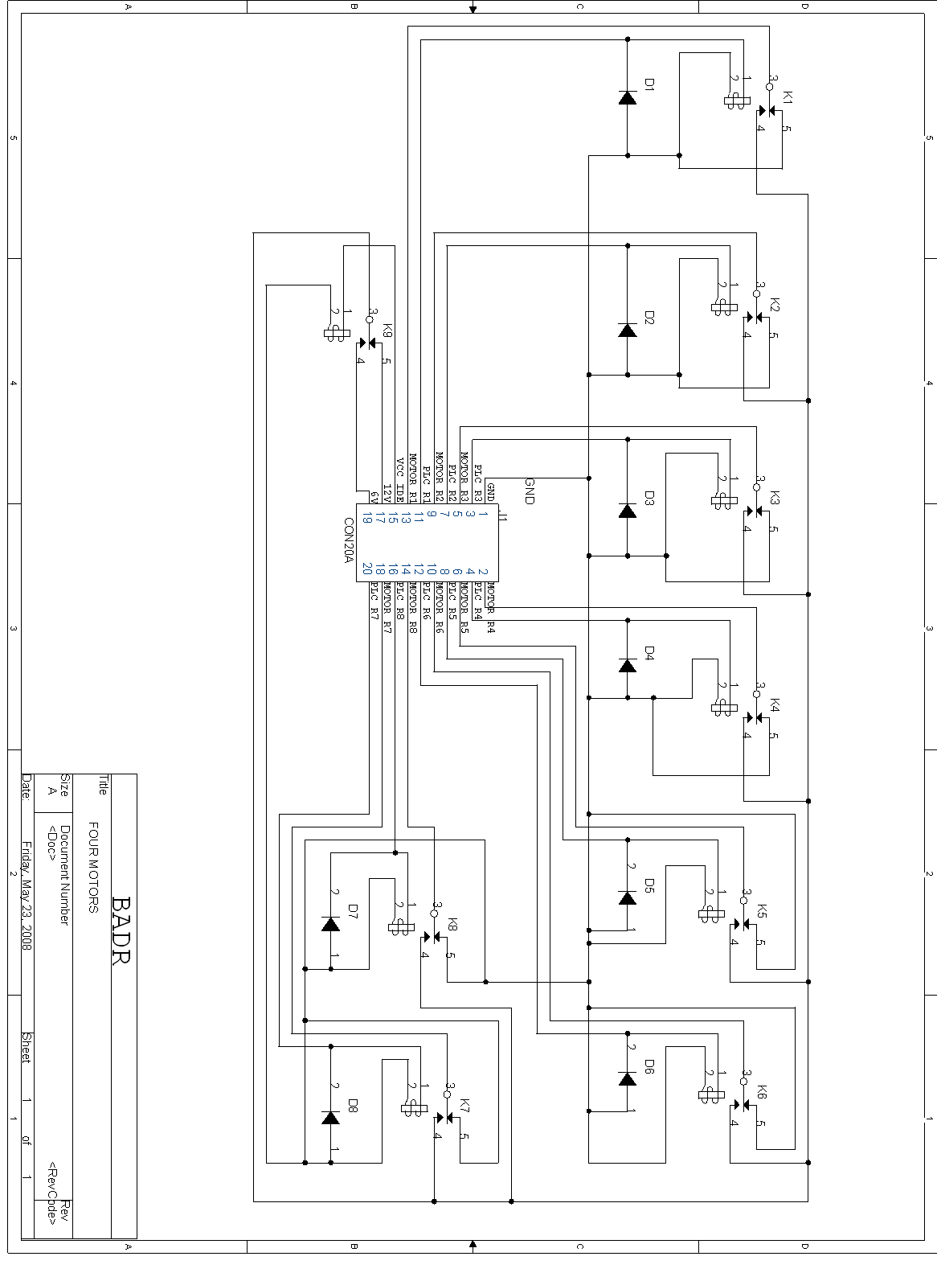
Figure B.1. Schematic circuit

B.1.2 Layout of motors driving circuit
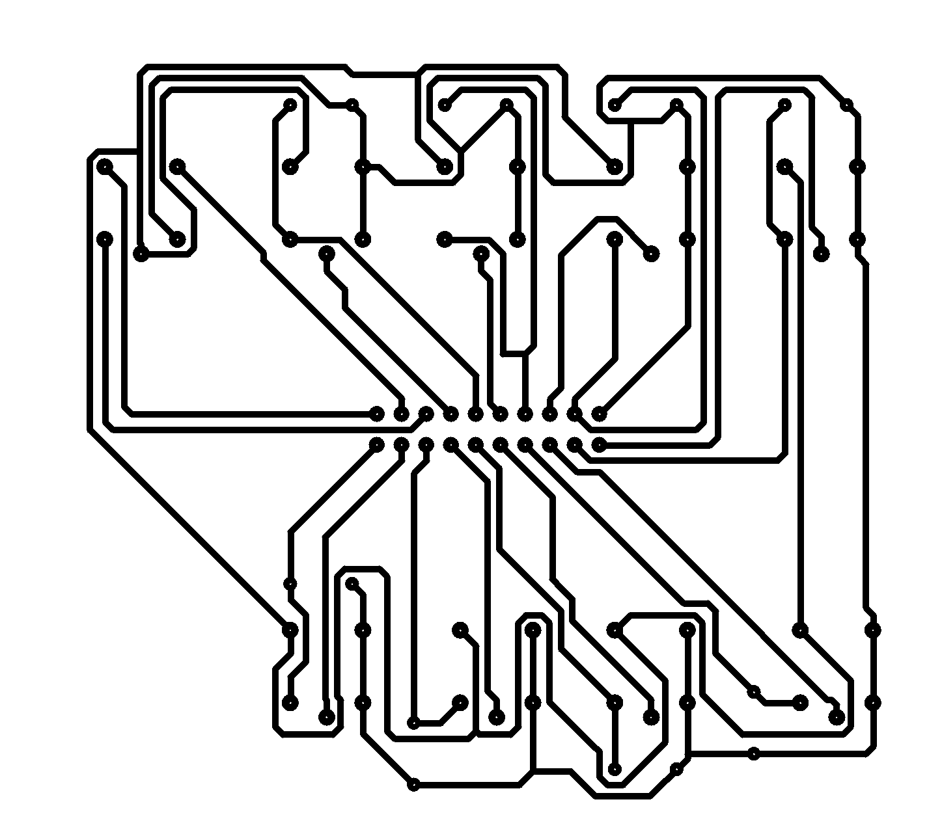

Figure B.2. Layout of motor driving circuit of automatic no.1

B.2 automatic robot no.2

B.2.1 Schematic of motors driving circuit
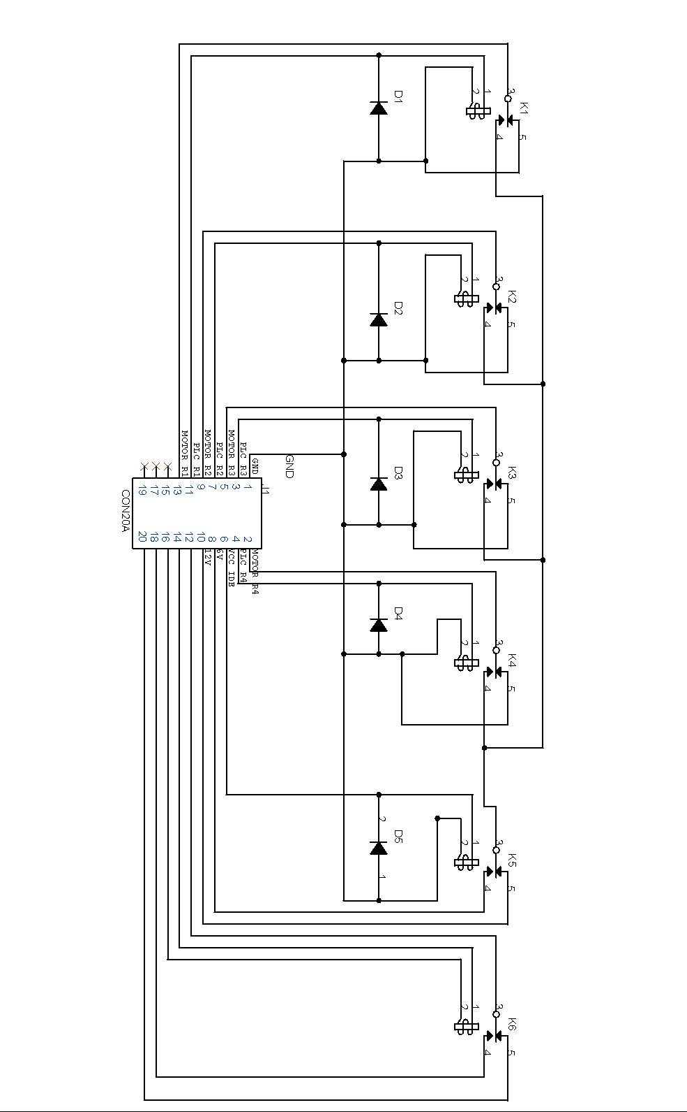

Figure B.3. Schematic of motor driving circuit of automatic no.2

B.2.2 Layout of motors driving circuit

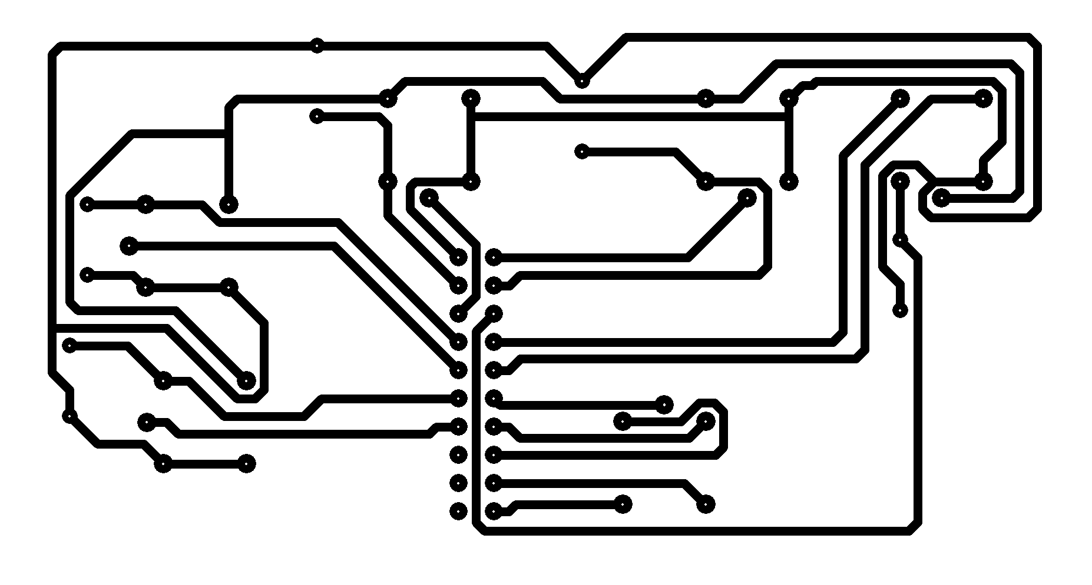

Figure B.4. Layout of motor driving circuit of automatic no.2

